What are Java Servlets?
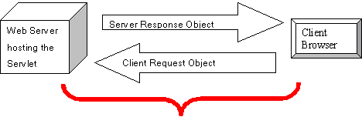
Servlets are server side components.These components can be run on any platform or any server due to the core java technology which is used to implement them. Servlets augment the functionality of a web application.They are dynamically loaded by the server's Java runtime environment when needed. On receiving an incoming request from the client, the web server/container initiates the required servlet. The servlet processes the client request and sends the response back to the server/container, which is routed to the client [1].

Figure 3: HTTP request response model.
Web based Client/server interaction uses the HTTP (hypertext transfer protocol). HTTP is a stateless protocol based on a request and response model [9] with a small, finite number of request methods like GET, POST, HEAD, OPTIONS, PUT, TRACE, DELETE, CONNECT, etc. The response contains the status of the response and meta information describing the response. Most of the servlet-based web applications are built around the framework of the HTTP request/response model (Figure 3).

Requirements to run Java Servlets
- Java Servlets require some prior working knoweldge of Java and HTML.
- Web applications and Web pages requiring initiation of servlets must run on web servers with built-in web containers, such as the iPlanet web server [4] or on a standalone servlet container like Tomcat [5]. The servlets may also run on application servers with built-in web containers like BEA WebLogic Server [2].
- The Servlet API (which we will shortly try to understand) is mostly built in the web container/server. The container/server achieves this by implementing the Java Servlet 2.1 or 2.2 specification [10]. For example, Tomcat 3.3 is compliant to Servlet API 2.2 and JSP API 1.1 specification [6].
Once the basic container/server is downloaded and configured, the next step is to understand servlet programming. The Servlet API has two packages: javax.servlet [7], which has classes and packages independent of protocols, and javax.servlet.http [7], which is more specific to HTTP protocol.

Servlet Structure and Lifecycle
Before going into the servlet lifecycle we need to understand the basic classes and interfaces used for implementing the servlet.

Public Interface Servlet
A servlet must directly or indirectly implement this interface. Like any other java interface this is also a collection of empty method signatures. The following methods are declared in the Servlet interface. [8]
- public abstract void init (ServletConfig config) throws ServletException. ---- The init method is used for initializing the servlet parameters provided by the ServletConfig object. It is called only once unless the servlet is reinitialized by destroying and subsequently reloading. The init method is the place to initialize the setup parameters like database connection, file initialization and other environmetal settings. None of the servlets methods can be called unless the servlet is initialized using the init() method.
- public abstract ServletConfig getServletConfig () ---- This method provides the ServletConfig object for initializing the servlet's parameters. Additional parameters can be created by specifying in the servlet.properties file. Once they have been specified in this file they can be accessed using the ServletConfig object.
- public abstract void service (ServletRequest req, ServletResponse res) throws ServletException, IOException. ---- The service method is the actual crux of the HTTP request response model. It recieves a client request in the form of ServletRequest object. The client parameters are also passed with the request object (though there are other ways also to send client-side parameters to the servlet, e.g. by using cookies or URL rewriting). The resulting response is sent to the client using the ServletResponse object.
- public abstract String getServletInfo() ---- This method is used for extracting the servlet meta data like author, servlet version, and other copyright information. The method will have to be overridden inside the servlet for it to return this information
- public abstract void destroy () ----- The destroy method is called in order to clear all retained resources like database and other server resources. It also takes care of synchronization of any pending threads. This method is called only once automatically, like the init method.
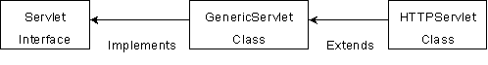
The GenericServlet class provides the basic implementation of the Servlet interface. To write a servlet specifically for the HTTP protocol, an HTTPServlet class that extends the GenericServlet class is used (Figure 4).

Figure 4: Relevant Servlets Classes and Interfaces
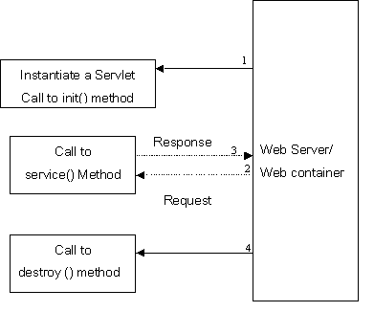
As discussed earlier the lifecycle events for a servlet (Figure 5) are specified in the javax.servlet.Servlet interface. All servlets follow the lifecycle model. The web container has the responsibility of creating an instance of the servlet and calling the init method (1). If a client has made a request to the web container then that request is passed to the service method (2) of the servlet and a response (3) is sent back to the web container. Finally when the servlet has finished its purpose then the web container calls the destroy (4) method.

Figure 5: Servlet Lifecycle
Apart from the methods that inherit from the GenericServlet class, the HTTPServlet class has additional methods for each of the HTTP request methods [9] discussed earlier.
- doDelete (HttpServletRequest, HttpServletResponse)
- doGet (HttpServletRequest, HttpServletResponse)
- doOptions (HttpServletRequest, HttpServletResponse)
- doPost (HttpServletRequest, HttpServletResponse)
- doPut (HttpServletRequest, HttpServletResponse
- doTrace (HttpServletRequest, HttpServletResponse)
For example the Servlet class has to override doGet or doPost (or both methods, depending on whether the data is being sent by GET or by POST HTTP request methods). These methods take two arguments: an HttpServletRequest and an HttpServletResponse object. These two objects give full access to all information about the client's request and help to control the output sent to the client as the response to the request. The doGet and doPost are called by the service method. The service method can directly be used by overriding it.

A Simple Servlet
To demonstrate the lifecycle of the servlet let us take a look at a simple servlet program. This program imports the basic servlet package for creating a servlet namely, javax.servlet. This program will implement the servlet interface. It defines the init method, which takes the parameter as a ServletConfig object for setting the properties of the servlet. It has a main service method which takes the request and response objects as parameters. The entire processing of the servlet revolves around these objects. The request from the client is enclosed in the request object and the response from the servlet is provided in the response object. This servlet just provides a simple response of printing a sentence as an html output.
import java.io.*;
import javax.servlet.*;
public SimpleServlet implements Servlet
{
private ServletConfig config;
public void init (ServletConfig config) throws ServletException
{
this.config = config;
// config object provides initialization parameters for the servlet.
}
public void destroy() { // can do some ending tasks here }
public void service (ServletRequest req, ServletResponse res) throws ServletException, IOException
{
res.setContentType( "text/html" ); // setting MIME type

PrintWriter out = res.getWriter();

// output stream for writing data on the client side
out.println (<html>" );
out.println( "<head>" ); //Generating Client Side Code
out.println( "<title>FIRST SERVLET</title>" );
out.println( "</head>" );
out.println( "<body>" );
out.println( "<h1>This is my First Servlet</h1>" );
out.println( "</body>" );
out.println( "</html>" );
out.close();
}

} // end of class ……………………. Once the servlet is compiled, it needs to be installed in the web container in its proper location or a default servlet directory. This varies from server to server; for iPlanet web servers [4], servlets may reside in the directory c:\netscape\server4\docs\servlets. Another option for the iPlanet web server is to configure the path in the servlets tab (servlet directory) of the iPlanet web server console so that it can locate the servlet program at runtime. Once the program is in its default directory, the client can invoke it by specifying the web address or URL in the browser.

